 

* **Install Power BI Desktop and share the final screenshot of the report view page which appears when power desktop starts.**

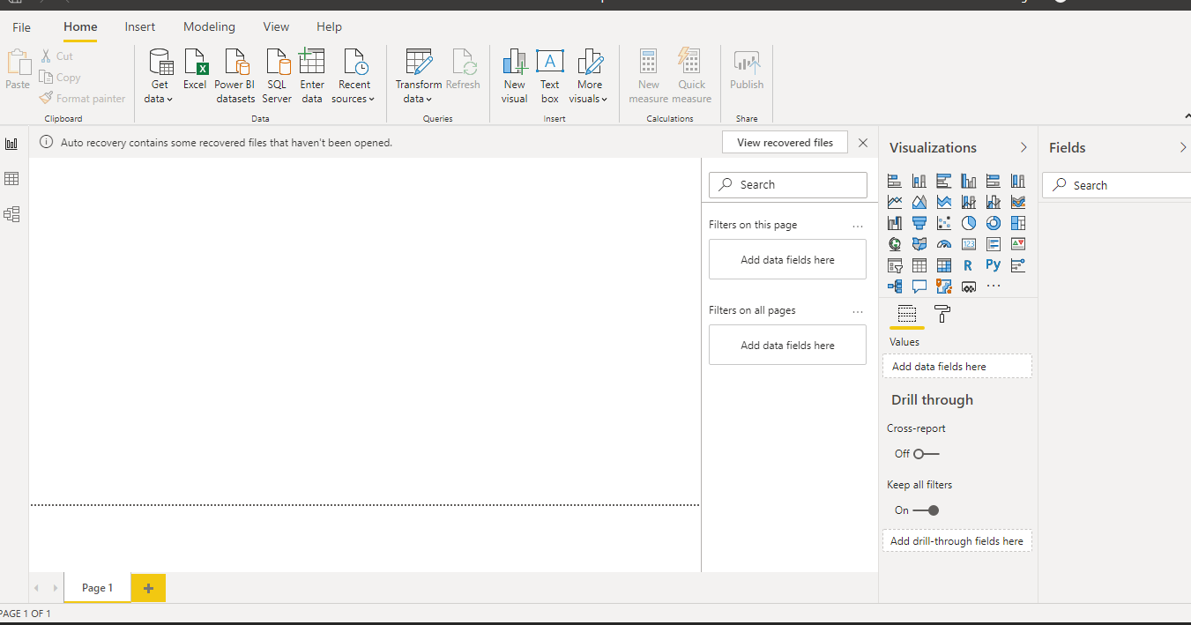

* **Prepare a document and with the following screenshot**
* **Report View**

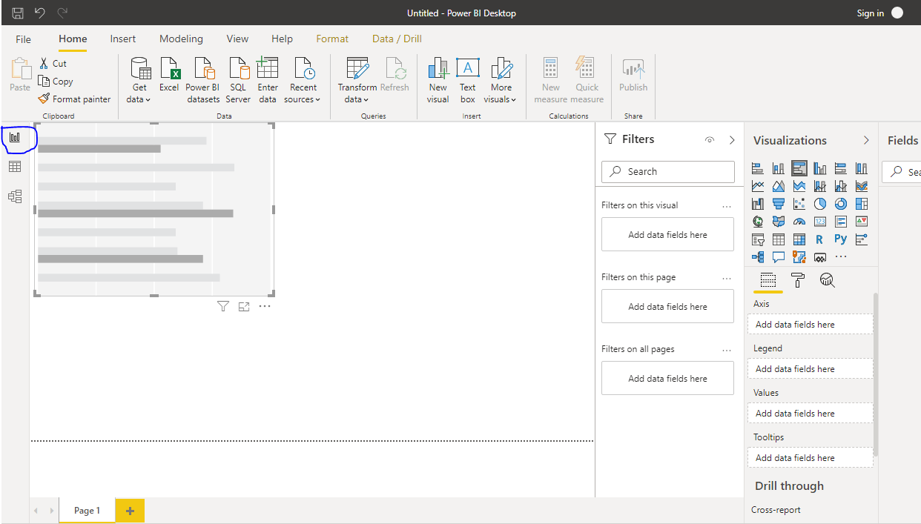

* Data View

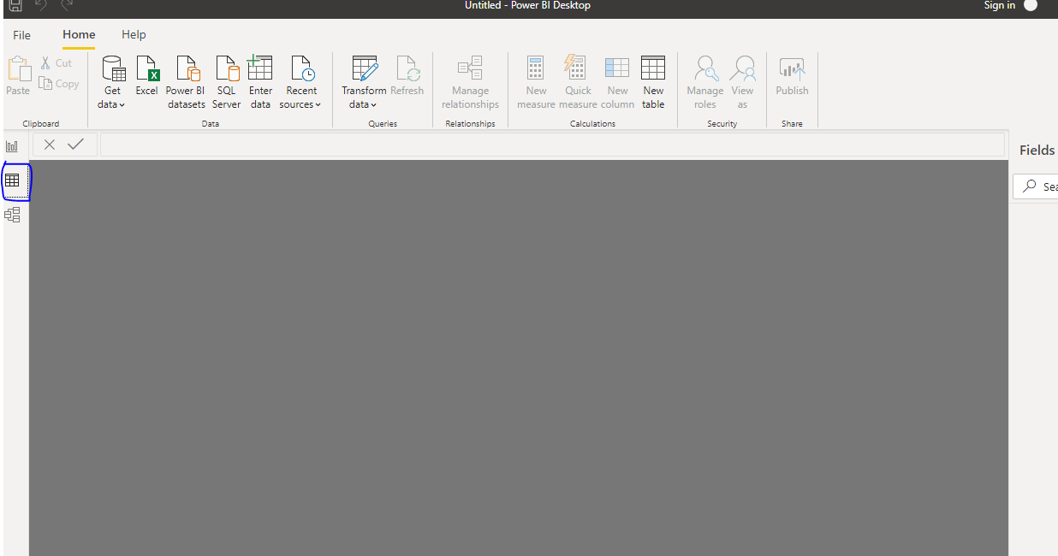

* Model View

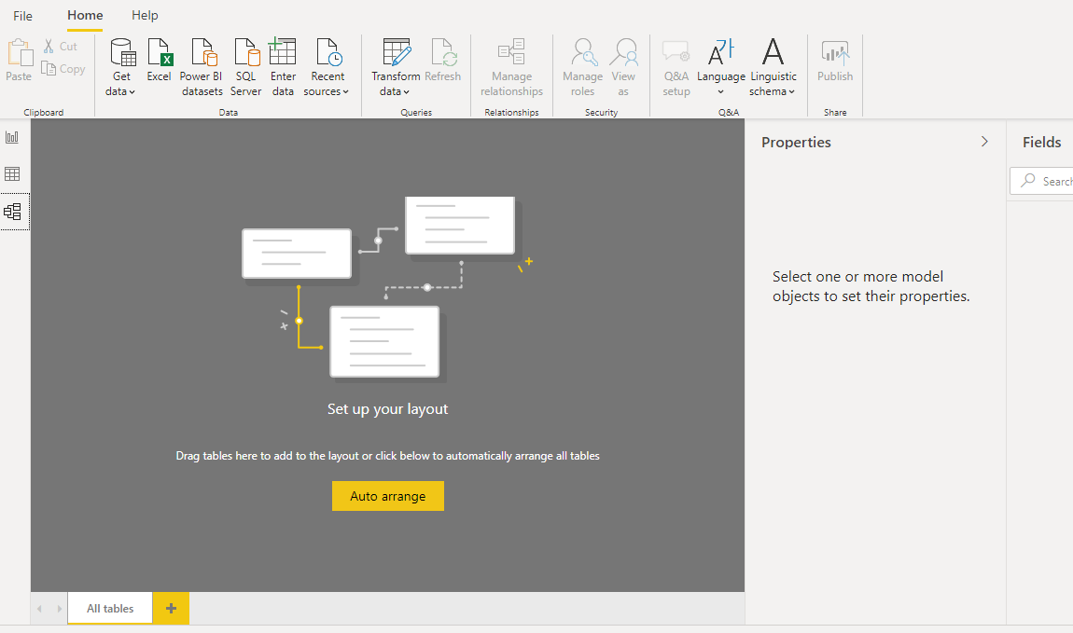

* Power Query Editor

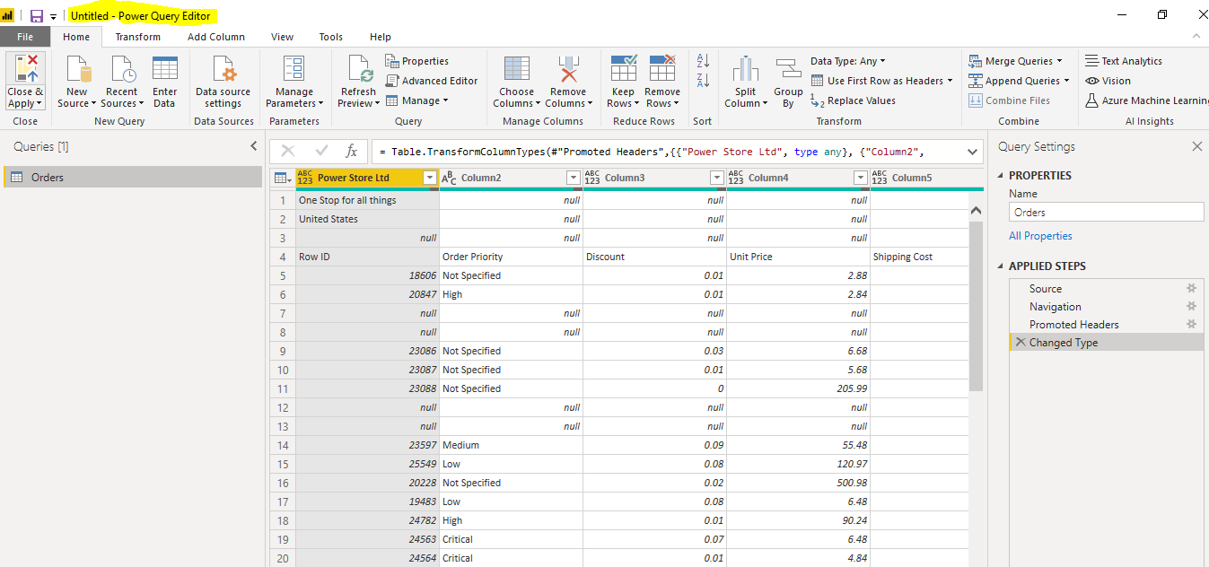

* Advance Editor

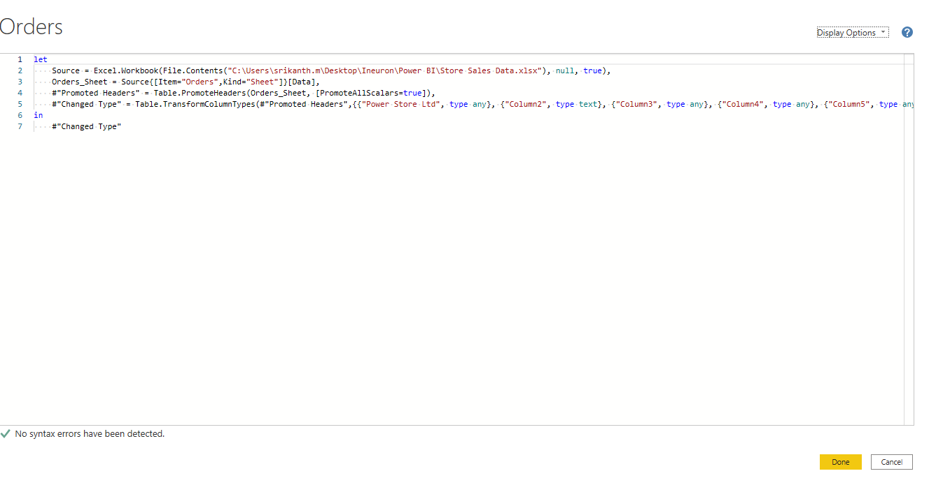

* Prepare a document with details of the following along with their price
* Power BI Desktop :

**Connect to your data, wherever it is**

Access data from hundreds of supported on-premises and cloud-based sources, such as Dynamics 365, Salesforce, Azure SQL DB, Excel, and SharePoint. Ensure it’s always up to date with automated, incremental refreshes. Power BI Desktop enables you to develop deep, actionable insights for a broad range of scenarios.

### Prep and model your data with ease

Save time and make data prep easier with data modeling tools. Reclaim hours in your day using the self-service Power Query experience familiar to millions of Excel users. Ingest, transform, integrate, and enrich data in Power BI.

**Pricing:**

This offering is free to any single user and includes data cleaning and preparation, custom visualizations and the ability to publish to the Power BI service. Power BI Pro: The Pro plan costs $9.99/user/month.

**Power BI Pro**

The biggest difference between Power BI Free & Power BI Pro lies in your ability to create and share dashboards with other team members. Power BI Pro users can publish content to app workspaces, share dashboards with other Power BI users and subscribe to dashboards and reports

**Price:**

Power BI Pro: The Pro plan costs $9.99/user/month. It includes data collaboration, data governance, building dashboards with a 360-degree real-time view and the ability to publish reports anywhere. Users can try it a free trial for 60 days before purchasing the subscription.

**Power BI Premium**

You can use Power BI Premium to get dedicated and enhanced resources for your organization, so users in your organization can use the Power BI service with better performance and responsiveness. For example, with a Power BI Premium subscription, you and your organization's users get access to:

Greater scale and performance

Flexibility to license by capacity

Unify self-service and enterprise BI

Extend on-premises BI with Power BI Report Server

Support for data residency by region (Multi-Geo)

Share data with anyone without purchasing a per-user license

